

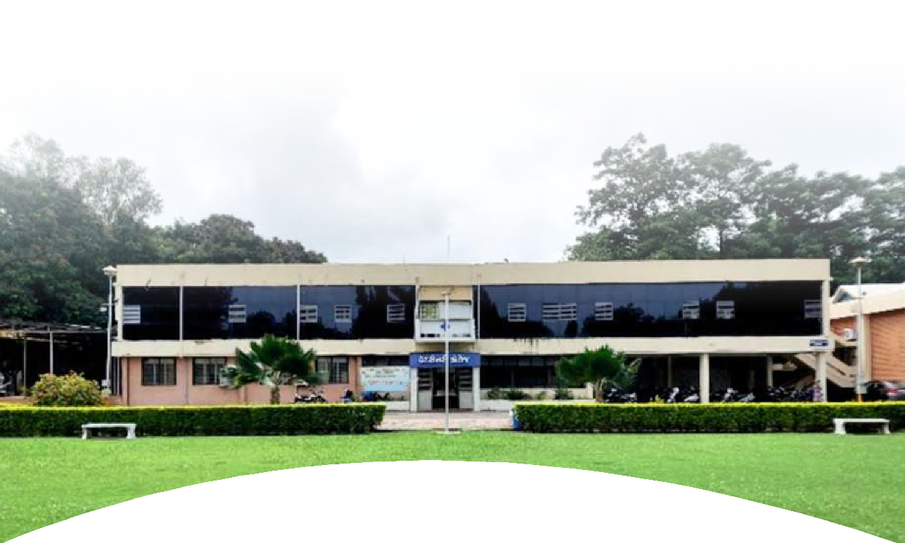
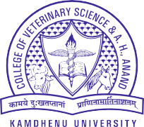





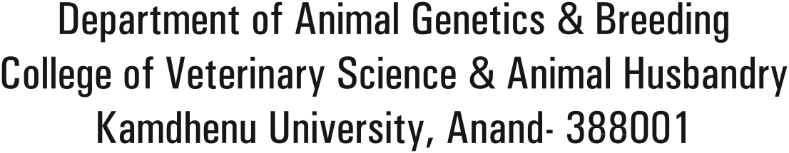


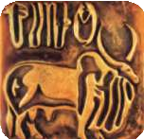
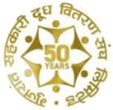



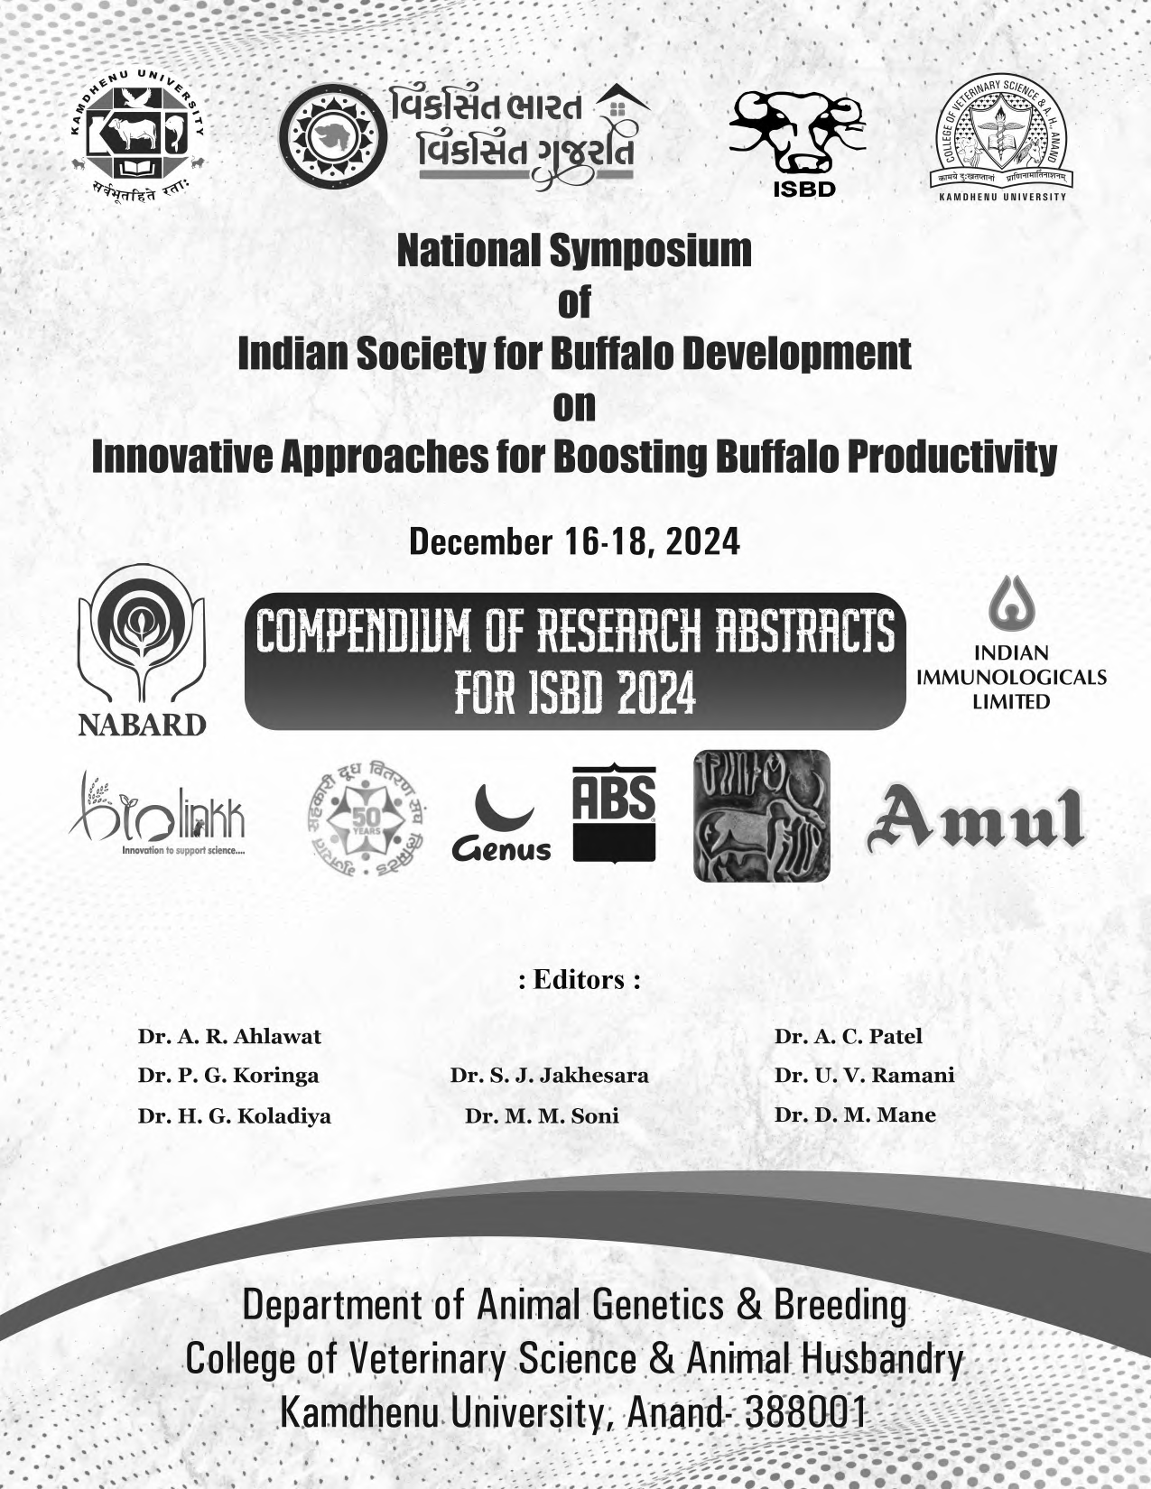


©Organizing Committee, ISBD-2024, Department of Animal Genetics & Breeding, College of Veterinary Science and Animal Husbandry, Kamdhenu University, Anand, Gujarat.
ii
College of Veterinary Science and Animal Husbandry, Kamdhenu University, Anand
All right reserved. Part of this publication may be reproduced for non-commercial use provided that such reproduction shall be subject to acknowledgment of ISBD-2024 as holder of copyright

Title : Compendium of Research Abstracts of National Symposium of Indian Society for Buffalo Development on “Innovative Approaches for boosting buffalo productivity”

Editors : Dr. A. R. Ahlawat, Dr. A. C. Patel, Dr. P. G. Koringa, Dr. S. J. Jakhesara, Dr. U. V. Ramani, Dr. H. G. Koladiya, Dr. M. M. Soni, Dr. D. M. Mane

Publication No. : KU-12-16-OT-03-2024

Publication Year : 2024

Copies : 200

Published By : Department of Animal Genetics & Breeding
College of Veterinary Science and Animal Husbandry, Kamdhenu University,
Anand-388 001, Gujarat (India)

Sponsored By : National Bank for Agricultural and Rural Development (NABARD)

Printed By : Asian Printery,
229/1, Bhutani Ambali, Nr. Talati Hall, Raipur, Ahmedabad-38001
Phone: 079-22148826

Disclaimer : “NABARD does not assume any responsititity for the contents published by “College of Veterinary Science and Animal Husbandry, Kamdhenu University, Anand”. NABARD does not hold any responsibility for the facts and figures contained in the report. The views are of the authors alone and should not be puported to be those of NABARD”

viii
College of Veterinary Science and Animal Husbandry, Kamdhenu University, Anand
TS-II-28 | COMPARATIVE URINE ENDOCRINE PROFILES OF DIFFERENT BREEDS OF CATTLE AND BUFFALOES IN GUJARAT  Parmar, C. P., Patel, J. H., Lunagariya, P. M., Wadhwani, K. N., Savaliya, B. D. and Sarvaiya, N. P. | 41
TS-II-29 | RETROSPECTIVE STUDY OF UTERINE TORSION IN MAHESANI BUFFALOES  Javiya, D. J., Sutaria, T. V., Chaudhari, R. K., Chaudhari, C. F. | 41
TS-II-30 | MANAGEMENT OF FETAL MACERATION IN BUFFALO  Thoriya, A. V., Sharma, H. C., Khasatiya, C. T. and Modi, L. C. | 42
TS-II-31 | THERAPEUTIC IMPACT OF THE HORMONAL REGIMEN ON THE MANAGEMENT OF POSTPARTUM ANESTRUS AND SUBESTROUS IN JAFFARABADI BUFFALOES  Vijyeta, H. P., Bhavsar, M. Y., Parikh, S. S., Chaudhary, J. K., Borkhatariya, D. N. and Gamit, P. M. | 42
TS-II-32 | COMPARING CONVENTIONAL AND FLOW CYTOMETRY BASED IN VITRO SPERM FUNCTION ASSAYS IN PREDICTING FIELD FERTILITY IN MESHANA BULLS  Damor, A. B., Hadiya, K. K., Layek, S. S., Kumaresan, A., Raval S. K. and Patil, S. P. | 43
Technical Session III Health and Diseases
SR. NO. | ORAL PRESENTATIONS | Pg. No.
TS-III-01 | BIOSYNTHESIS OF SILVER NANOPARTICLES WITH ANTIMICROBIAL PROPERTIES USING TWO PLANT EXTRACTS  Kanwar, A., Virmani, M., Rajesh Kumar and Lakhani, P. | 47
TS-III-02 | HAEMATO-BIOCHEMICAL AND HORMONAL PROFILES AS PREDICTOR OF POST-OBSTETRICAL SURVIVAL OF UTERINE TORSION AFFECTED MEHSANA BUFFALOES  Chauhan, P. M., Sharma V. K. and Prajapati, A. S. | 47
TS-III-03 | HEMATOLOGICAL ALTERATIONS OF AMPHISTOMOSIS INFECTED BUFFALOES AND ITS THERAPEUTIC MANAGEMENT  Patel, B. R., Vasava, A. A., Patbandha, T. K., Nimavat, V. R., Prajapati, A. S., Sadhu, D. B., Rao, N. M. and Joseph, J. P. | 48
TS-III-04 | INTROSPECTIVE INTERSPECIES DIFFERENCE IN INTRAVENOUS PHARMACOKINETIC OF MELOXICAM  Patel, H. A., Mody, S. K. and Patel, H. B. | 49
TS-III-05 | THERAPEUTICS MANAGEMENT OF PREPARTUM VAGINAL PROLAPSE BY TRADITIONAL MEDICINE IN JAFFRABADI BUFFALOES  Bhojani, R. J., Patel, M. D. and Mehta, S. A. | 49


College of Veterinary Science and Animal Husbandry, Kamdhenu University, Anand
ix
TS-III-06 | DEVELOPMENT OF INCISOR TEETH IN MEHSANA BUFFALO  (Bubalus bubalis): THE RADIOGRAPHIC STUDY  Patel, K. B., Joshi, N. H., Chudasama, M. M., Patel, H. N. and Desai, M. C. | 50
TS-III-07 | MAXILLARY AND MANDIBULAR DENTAL ARCADES BIOMETRY IN  MEHSANA BUFFALO (Bubalus bubalis)  Patel, K. B., Joshi, N. H., Patel, H. N., Chudasama, M. M. and Desai, M. C. | 50
TS-III-08 | CLINICO-PATHOLOGICAL STUDIES OF PULMONARY AFFECTIONS IN RELATION TO HAEMATO-BIOCHEMICAL PARAMETERS AND THERAPEUTIC EVALUATION IN DOMESTIC WATER BUFFALOES  (Bubalus bubalis)  Jajoria, C., Tarun Kumar, Sindhu, N.,Sharma, M., Joshi, V. G., Saharan, S. and Agnihotri, D. | 51
TS-III-09 | MANAGEMENT OF BUBALINE TUMORS: A REVIEW OF 12 CASES  Mecvan, A. R., Mahla, J. K., Patel, B. M. and Parikh, P. V. | 52
TS-III-10 | PREVALENCE AND CLINICAL IMPACT OF TOXOCARA VITULORUM IN JAFFRABADI BUFFALO CALVES (Bubalis bubalis) IN AND AROUND JUNAGADH, GUJARAT, INDIA  Gamit, K. C., Odedara, M. D., Gamit, V. V. and Thakre, B. J. | 52
TS-III-11 | SUCCESSFUL SURGICAL MANAGEMENT OF RIGHT LATERAL ABDOMINAL HERNIA BY HERNIOPLASTY USING NYLON PLASTIC MESH IN BUFFALO HEIFER  Suthar, D. N., Patel, T. P., Raygaur, B. K., Chauhan, K. K. and Sheth, K. M. | 53
TS-III-12 | CULLING REASONS AT NILI RAVI BUFFALO FARM OF ICAR-CIRB, SUB CAMPUS, BIR DOSANJH, NABHA (PUNJAB) DURING THE YEAR 2020  Singh, R. and Saini, A. K. | 53
TS-III-13 | SUCCESSFUL SURGICAL MANAGEMENT OF BRISKET TUMOURS IN BUFFALOES  Shah, A., Mayani A., Patel, A., Bhalodi, A.and Parmar, J. | 54
TS-III-14 | SUCCESSFUL SURGICAL MANAGEMENT OF INTESTINAL INTUSSUSCEPTION WITH ENTEROANASTOMOSIS IN A BUFFALO  Mayani, A., Shah, A., Parmar, J., Patel, S., Patel, A. and Bhalodi, A. | 54
TS-III-15 | HYPOPHOSPHATEMIA IN A BUFFALO  Joseph, J. P., Patel, B. R., Vasava, A. A., Prajapati, A. S., Rao, N. M., Sadhu, D. B. and Shah, A. I. | 55
TS-III-16 | ULTRASONOGRAPHY: A DECIDING TOOL FOR SURGICAL TREATMENT IN MALE BUFFALOES SUFFERING FROM OBSTRUCTIVE UROLITHIASIS  Saharan, S., Poonia A., Kumar, A., Tiwari D., Sindhu, N., Tarun Kumar, Sharma,  M. and Singh G. | 55
TS-III-17 | CLINICAL ATTRIBUTES OF TRAUMATIC PERICARDITIS AND TRAUMATIC RETICULOPERITONITIS IN BUFFALOES  Prajapati, A. S., Chauhan, P. M., Shah, A. I., Parmar, J. J., Patel, B. R., Joseph, J. P. | 56

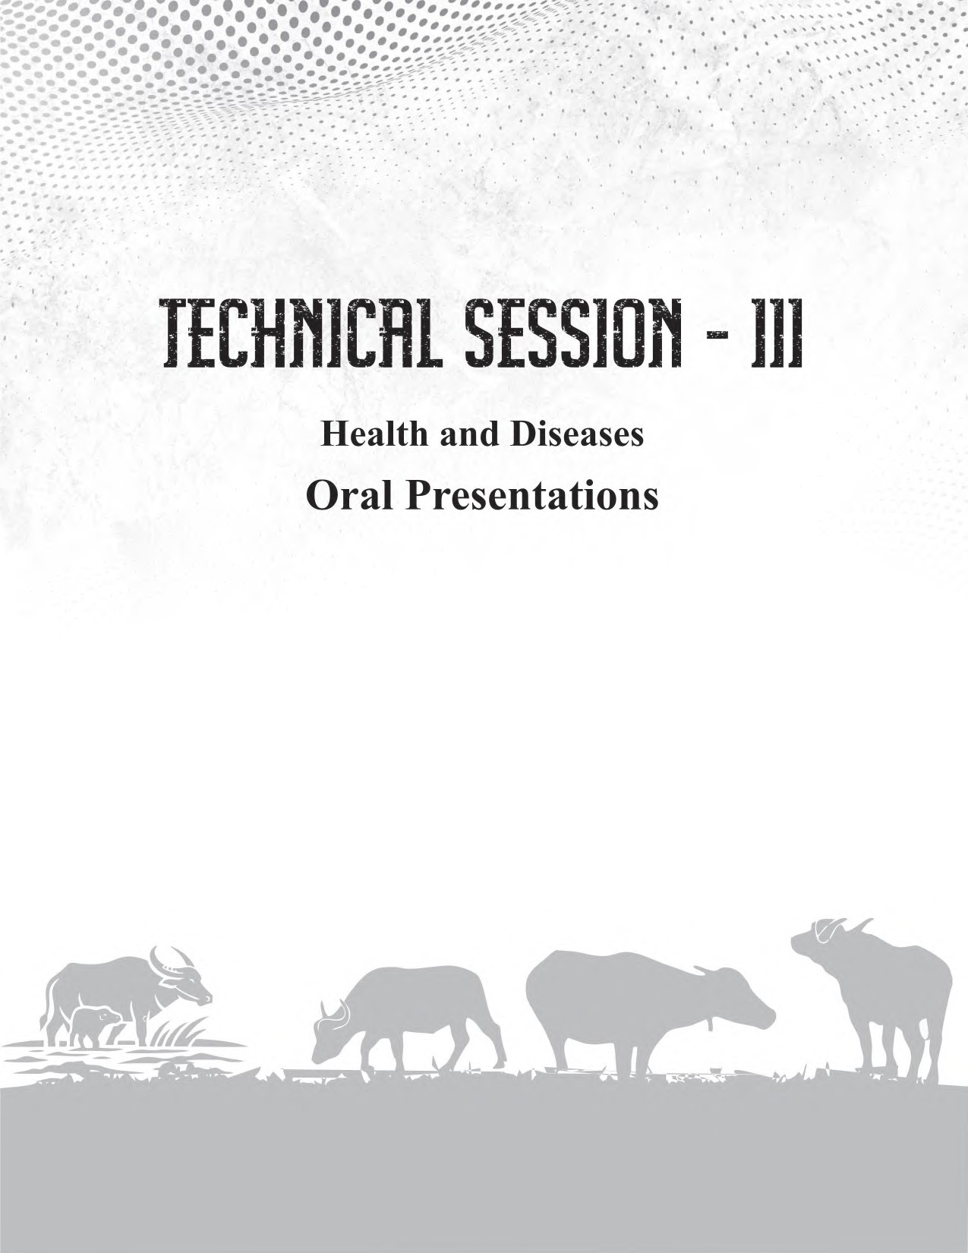

Abstract-TS-III-01
College of Veterinary Science and Animal Husbandry, Kamdhenu University, Anand
47

BIOSYNTHESIS OF SILVER NANOPARTICLES WITH ANTIMICROBIAL PROPERTIES USING TWO PLANT EXTRACTS
Kanwar, A., Virmani, M., Rajesh Kumar and Lakhani, P.
E-mail ID: virmanim2003@yahoo.com

Prolonged use of antibiotics has led to growing bacterial resistance, which in turn requires higher doses to achieve the same effect, further accelerating the antimicrobial resistance (AMR). This AMR has driven the researchers to seek alternative antimicrobial agents. Silver, known for its strong bacteriostatic and disinfectant properties, offers a promising solution. Silver, in form of nanoparticles, exhibits even more potent antibacterial effects, making nano-silver particularly advantageous for antimicrobial applications. In the present study, both ethanolic and aqueous extracts of Ashwagandha root powder and clove flower bud were used for producing biological silver nanoparticles (AgNPs) from silver sulphate. The biosynthesized AgNPs produced by Ashwagandha root powder and clove flower bud extracts showed a strong plasmon resonance around 425-435 nm wavelength on UV-Vis spectroscopy and had average sizes approximately
212.2 - 216.3 nm, with uniform size distributions. The antibacterial activities of all the four type of AgNPs were evaluated using the agar well diffusion method against Escherichia coli, Staphylococcus aureus, Streptococcus dysgalactiae, and Pseudomonas aeruginosa. The diameter of the zone of inhibition was measured with the help of vernier callipers to determine the antibacterial activity. The size of zone of inhibition was found to be more in ethanolic NPs compared to their aqueous counterparts for both the Gram negative and Gram positive bacteria. Further the ethanolic NPs were characterized by Zeta potential measurements, Transmission Electron Microscopy (TEM), X-ray diffraction (XRD) and Raman spectroscopy, which indicated stability, spherical shape, crystalline nature, with prominent peaks indicating face-centered cubic structures of the silver nanoparticles. These findings underscore the efficacy of ethanolic plant-based extracts in synthesizing stable and uniform silver nanoparticles with potential antibacterial activity.

Abstract-TS-III-02

HAEMATO-BIOCHEMICAL AND HORMONAL PROFILES AS PREDICTOR OF POST- OBSTETRICAL SURVIVAL OF UTERINE TORSION AFFECTED MEHSANA BUFFALOES
Chauhan, P. M., Sharma V. K. and Prajapati, A. S. E-mail ID: pmchauhan@kamdhenuuni.edu.in

The present investigation was conducted on 78 uterine torsion affected Mehsana buffaloes divided into survived (n=52) and non-survived groups (n=26) following delivery of the fetus to evaluate haemato- biochemical and hormonal levels/concentrations of RBC, PCV, Hb, WBC, TLC, DLC, TP, Cp, Cr, BUN, cortisol, T3 and T4values as a predictor of post-obstetrical survival of dam. The blood samples from buffaloes of both groups were collected initially on day of hospitalization, after delivery of the fetus followed by 24 hour later and then on day 3, 5 and 10 of obstetrical manoeuvers. The blood samples were also obtained from normal parturient buffaloes (n=6) at similar intervals for comparison of data. The blood plasma was

dentition, grinding function was highest in Dp . The upper molars were relatively wider than lower molars. The left and right arcades of lower cheek teeth were almost parallel and straight. The maxillary arcades were concave medially. The distances between right and left cheek teeth arcades were relatively wider in the upper jaw than in the lower jaw. This resulted in unequal sizes of jaws forming anisognathous type dentition in buffalo.
College of Veterinary Science and Animal Husbandry, Kamdhenu University, Anand
51
3

Abstract-TS-III-08

CLINICO-PATHOLOGICAL STUDIES OF PULMONARY AFFECTIONS IN RELATION TO HAEMATO-BIOCHEMICAL PARAMETERS AND THERAPEUTIC EVALUATION IN
DOMESTIC WATER BUFFALOES (Bubalus bubalis)
Jajoria, C., Tarun Kumar, Sindhu N., Sharma, M., Joshi, V. G., Saharan, S. and Agnihotri, D. E-mail ID: drneeleshsindhu@luvas.edu.in

Domestic water buffaloes (Bubalus bubalis) are the backbone of Indian dairy industry by contributing more than 55% of total milk produced by Indian livestock. Pulmonary affections are major concern in bovines, responsible for devastating economic losses to farmers in terms of decreased milk production, loss of animal etc. Present study was carried out over a period of 8 months in the University Referral Hospital. A total of 57 buffaloes were suspected for either pulmonary affection or cardiac diseases. Clinical signs, haemato-biochemical changes, thoracic radiography was done for final diagnosis. For image evaluation, radiographic evaluation grid was developed and observations were recorded in the grid. Clinical scoring was done separately for pulmonary cases to determine severity of cases as well as to evaluate the therapeutic regimen. A total of thirty-one buffaloes (54.38%) were confirmed to be of having pulmonary affection. Cardinal signs recorded in pulmonary affected animals were mainly nasal discharge, coughing and respiratory distress. crackles in lungs and muffled heart sound. Out of thirty-one cases crackles was heard in maximum (24) cases, whereas in seven cases no lung sound was recorded. Haemato-biochemical changes in pulmonary affected buffaloes revealed neutrophilic leucocytosis with increase in LDH and PCV. Protein and serum albumin was significantly decreased in all affected cases. Out of thirty-one cases, radiographs of 47% cases were clear in details and able to characterized into different pneumonic pattern like bronchial, interstitial and broncho-interstitial pattern, whereas in 53 % cases hazzyness or poor thoracic details due to chest pathology or hydrothorax changes was recorded. Animals were divided randomly into two groups, group 1 was treated with enrofloxacin @ 12.5 mg/kg and Group 2 was treated with ceftiofur sodium @ 2 mg/kg. Therapeutic evaluation was done on the basis of percent decrease in clinical score and it was found that enrofloxacin along with supportive therapy showed better improvement in pulmonary affections as compared to animals treated with ceftiofur sodium and supportive therapy.

polyglactin 910 no. 1 by lock stich pattern separately. The skin was apposed by interrupted suture technique with nylon no. 2. The buffalo has passed faeces within two hours of surgery. Post-operatively buffalo was treated with earlier treatment for five days along with antiseptic dressing till healing. The owner also advise to fast buffalo for five days. The skin sutures were removed thirteenth day postoperative day. Both buffaloes were recovered uneventfully.
College of Veterinary Science and Animal Husbandry, Kamdhenu University, Anand
55

Abstract-TS-III-15

HYPOPHOSPHATEMIA IN A BUFFALO
Joseph, J. P., Patel, B. R., Vasava, A. A., Prajapati, A. S., Rao, N. M., Sadhu, D. B. and Shah, A. I. E-mail ID: joice.joseph@kamdhenuuni.edu.in

Hypophosphatemia is one of the major production disease in buffalo especially around parturition. But it can happen in other lactation stages also. One buffalo aged eight year was presented with history of reddish milk and urine and was not responding to common supportive medications. No history of recent parturition also. Clinical examination and common laboratory examination including blood smear examination didn’t reveal the etiology except mild anemia. Serum sample of the buffalo was tested for estimating calcium, phosphorus and magnesium. Calcium and magnesium levels were found normal and phosphorus level was decreased to 1.4 mg/dL. Animal was supplemented with phosphorus parenterally (sodium acid phosphate 60g in 300 mL of sterile water) and orally for one week resulting in uneventful recovery. Laboratory examination and response to treatment confirmed hypophosphatemia in the buffalo. Reduced phosphorus level results in reduced erythrocyte concentrations of ATP causing increased osmotic fragility of erythrocytes causing symptoms similar to hemoprotozoan diseases. So metabolic profiling of buffaloes are necessary to avoid production diseases, thereby increasing productivity.

Abstract-TS-III-16

ULTRASONOGRAPHY: A DECIDING TOOL FOR SURGICAL TREATMENT IN MALE BUFFALOES SUFFERING FROM OBSTRUCTIVE UROLITHIASIS
Saharan, S., Poonia, A., Kumar, A., Tiwari D., Sindhu, N., Tarun Kumar,Sharma, M. and Singh, G. E-mail ID: saharan007@gmail.com

The present study was conducted on 20 male buffaloes suffering from obstructive urolithiasis. On the basis of ultrasonography, these cases were divided into two groups i.e. Group I (n=10, urethral concretions). In this group the average age of the animals were 3.5 months. Group II (n=10, urethral calculi). The average age was 22 months. The aim of the study was to evaluate the diagnostic method, best surgical technique and chemical composition of uroliths. The animals showed clinical signs of anorexia, depression, kicking at abdomen, tail twitching, urethral pulsation, dribbling of blood tinged urine and distended lower abdomen. B-mode ultrasonography was performed using curvilinear and linear transducer of 6-8 MHz frequencies for urinary bladder and urethra, respectively. In Group I, small irregular concretions were present with composition of calcium carbonate, whereas in group II, calculus were large, rough, firm and composed

of calcium oxalate. In group I, ultrasound guided tube cystotomy were performed in eight cases, whereas in two cases tube cystotomy was performed with open surgical methods. Group II were managed by urethrotomy. Post operatively, antibiotic Inj. ceftriaxone @ 10 mg/Kg intramuscular for 5 days and anti- inflammatory and analgesic Inj. Meloxicam @ 0.2 mg/Kg intramuscular for 3 days were given. Ammonium chloride was given @ 50 mg/Kg orally for 30 days as urinary acidifier in group I. Thus. it was concluded that ultrasonography was significant in locating the uroliths and thus determining the site of incision and surgical technique. Further, the chemical composition of uroliths can help managing the diet of the animal for avoiding the reoccurrence.
56
College of Veterinary Science and Animal Husbandry, Kamdhenu University, Anand

Abstract-TS-III-17

CLINICAL ATTRIBUTES OF TRAUMATIC PERICARDITIS AND TRAUMATIC RETICULOPERITONITIS IN BUFFALOES
Prajapati, A. S., Chauhan, P. M., Shah, A. I., Parmar, J. J., Patel, B. R., Joseph, J. P. E-mail ID: ankitprjpt1@kamdhenuuni.edu.in

Traumatic injuries caused by foreign bodies are a common cause of traumatic pericarditis (TP) and traumatic reticuloperitonitis (TRP) in buffaloes, often presenting similar clinical signs in field conditions. This study evaluated the clinical, hematobiochemical, and ultrasonographic differences between TP and TRP cases. A total of twelve buffaloes were included in the investigation, with six affected by TP, six by TRP, and six healthy animals serving as controls. Various clinical signs, hematobiochemical parameters, and ultrasonographic findings were recorded and compared across the groups. Notable clinical findings included brisket edema in buffaloes with TP and an arched back in those with TRP. Ferroscopy was conducted to confirm the location of the foreign body. Jugular pulsation was observed in both the TP and TRP groups. In the TRP group, there was a significant increase in white blood cell (WBC) count and a decrease in hematocrit compared to healthy animals. Additionally, levels of serum glutamic-oxaloacetic transaminase (SGOT) and fibrinogen were significantly elevated in both affected groups. The most consistent ultrasonographic findings were anechoic fluid accumulation in TP and thickening of the reticular wall in TRP.
Keywords: Buffaloes, fibrinogen, foreign body, pericarditis, reticuloperitonitis, ultrasonography

Abstract-TS-III-18

MANAGEMENT OF UPPER GIT FOREIGN BODIES IN BUBALINE: A REVIEW OF 11 CASES
Patel, B. M., Mahla, J. K., Mecvan, A. R. and Parikh, P. V. E-mail ID: patelbhamini786@gmail.com

Clinical cases of adult buffaloes (n=10) of varying breeds had suspected foreign bodies were referred to the Department of Veterinary Surgery and Radiology, Kamdhenu University, Anand with a history of decreased appetite to anorexia with or without bloat. On physical examination 7 buffaloes had abnormal mass palpated at the neck region, while 3 were detected metallic foreign bodies with the help of ferroscopy, where 1 buffalo

